AI FAQ Assistant – Customer Support Chatbot
TEAM MEMBERS :
1. ALIA FATHIMA .S
2. AMMU.S
3. ANISA BEGAM.A
4. BASILATH UNNISHA.J
5. SYED ALI FATHIMA.Z

1. Introduction
The AI FAQ Assistant is an intelligent chatbot designed to provide quick answers to frequently
asked customer questions.
It helps users get information about orders, shipping, FAQs, and other customer-support-
related queries through a simple chat interface.
The system uses a backend developed with Node.js and Express.js, with MongoDB for
storing application data. AI functionality is integrated using Google Gemini AI.
2. Problem Statement
Traditional customer support requires users to wait for an employee to answer repetitive
questions.
The main problems are:
• Repeated customer queries
• Time-consuming manual responses
• Difficulty managing large numbers of FAQs
• Slow information retrieval
• Difficulty maintaining and organizing FAQ content
The project aims to provide an automated solution for answering common customer questions.
3. Proposed Solution
The AI FAQ Assistant provides an interactive chatbot where customers can type their questions
and receive relevant responses.
The system can:
• Answer frequently asked questions
• Search available FAQ information
• Provide order-related assistance

• Generate AI-assisted answers
• Organize FAQs into categories
• Allow authorized users to manage FAQ records
• Provide secure user authentication
4. Objectives
1. To provide automated customer support.
2. To reduce repetitive manual customer-service work.
3. To provide quick answers to frequently asked questions.
4. To make FAQ searching easier.
5. To generate AI-assisted responses.
6. To securely manage users and FAQ data.
7. To organize FAQs into different categories.
5. Technologies Used
Technology Purpose
HTML/CSS User interface
JavaScript Frontend interaction
Node.js Backend runtime
Express.js REST API and server
MongoDB Database
Mongoose Database modeling
Google Gemini AI AI-based responses and FAQ generation
JWT User authentication
bcrypt Password security
Postman API testing
The project document specifies Node.js, Express.js, MongoDB/Mongoose, Postman or
ThunderClient, JWT, bcrypt, and Google Gemini integration.

6. Main Modules
1. Login Module
The login page allows users to select their role:
• Customer
• Manager
• Admin
The user enters their email and password to access the system.
2. Customer Dashboard
After login, the customer is taken to the dashboard.
The dashboard displays:
• Number of chats
• FAQ entries
• Orders
• Orders in transit
• Chat history
3. AI Chatbot Module
Users can type questions such as:
"Where is my order?"
The AI Assistant processes the query and provides a relevant response.
4. FAQ Management
The system stores FAQ questions and answers and organizes them into categories.

Authorized users can:
• Create FAQs
• View FAQs
• Edit FAQs
• Delete FAQs
• Search FAQs
The project supports complete CRUD operations for FAQ records.
5. AI FAQ Generation
Google Gemini AI can generate FAQ questions and answers based on a given topic.
The project document describes AI-generated questions, answers, and topic suggestions.
6. Search Module
Users can search FAQs using keywords. The system retrieves matching FAQ documents
through keyword and semantic matching.
7. Authentication and Security
The project uses:
• JWT for authentication
• bcrypt for password hashing
• Protected routes for authorized users

8. Project Architecture
The project follows a layered server architecture with an MVC-based structure.
USER
↓
FRONTEND / UI
↓
EXPRESS.JS SERVER
↓
AUTHENTICATION MIDDLEWARE
JWT + BCRYPT
↓
CONTROLLER / SERVICES
↙ ↘
FAQ MODULE AI MODULE
↓ ↓
MONGOOSE GOOGLE GEMINI AI
↓ ↓
└───────┬────────┘
↓
MONGODB
↓
RESPONSE
↓
USER
Architecture Components
1. Interface Layer
• Provides the user interface.
• Users interact with the chatbot and FAQ system.

2. Express Server Gateway
• Handles HTTP requests.
• Supports GET, POST, PUT and DELETE operations.
• Processes JSON requests.
3. Authentication Middleware
• Validates JWT tokens.
• Controls access to protected routes.
4. Controller / Logic Layer
• Processes user requests.
• Applies application logic.
• Communicates with models and services.
5. Database Interface Layer
• Uses Mongoose to communicate with MongoDB.
• Handles data storage and validation.
6. AI Flow
• Uses Google Gemini SDK integration.
• Handles AI-based question answering and FAQ generation.
The architecture and its components are described in the project document.

9. User Flow
User | opens | website
↓
Login | / | Select | Role
↓
Customer Dashboard
↓
Ask | a | Question
↓
AI | Assistant | Processes | Question
↓
Relevant | Answer | is | Displayed
↓
Continue Chat / Search FAQs
10. Actual Output Screens
Output 1 – Login Page
The login page provides three role options:
Customer | Manager | Admin
The customer enters their email and password and signs in.

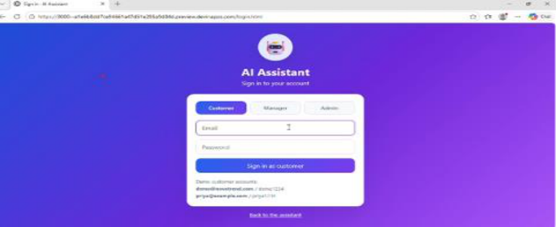
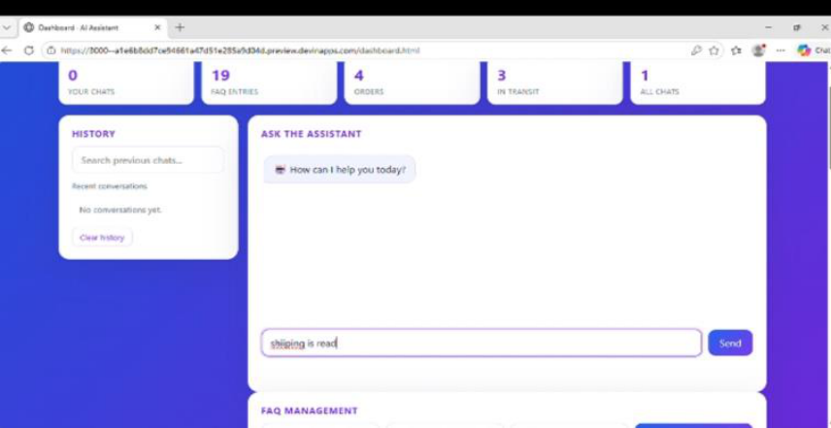

Output 2 – Customer Dashboard
The dashboard displays:
• Your Chats
• FAQ Entries
• Orders
• Orders in Transit
• History
• Ask the Assistant section.
Output 3 – Order Query
The customer enters:
"Where is my order?"

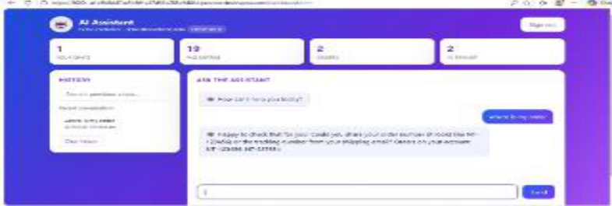
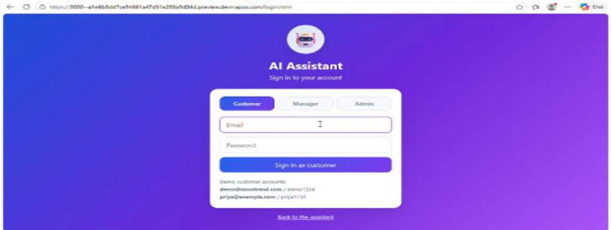

The AI Assistant responds by requesting the customer's order/shipping number or registered
email.
Output 4 – AI Assistant Home Page
The main page displays:
AI Assistant
Your Shopping Support It provides a chat interface where customers can ask shopping-
related questions.
11. FAQ Questions
Use these questions in your actual FAQ section:
1. How can I track my order?
2. How can I cancel my order?
3. How can I change my delivery address?
4. What payment methods are available?

5. Is cash on delivery available?
6. How long does delivery take?
7. How can I return a product?
8. When will I receive my refund?
9. Can I exchange a product?
10. How can I contact customer support?
12. Advantages
• Fast response to customer queries
• Reduces repetitive support work
• Easy FAQ management
• AI-powered responses
• Secure authentication
• Organized information
• Keyword-based FAQ search
• Scalable backend architecture

13. Conclusion
The AI FAQ Assistant provides an intelligent and user-friendly solution for automated
customer support. It combines a chatbot interface with FAQ management, AI-generated
content, search functionality, authentication, and database management.
The system helps users find information quickly while reducing repetitive work for customer-
support staff.

